# Test Cases

**Case 1: Add Employee**

GIVEN an Employer  
AND I am on the Benefits Dashboard page  
WHEN I select Add Employee  
THEN I should be able to enter employee details  
AND First Name does not begin with “A” or “a”  
AND the employee should save  
AND I should see the employee in the table  
AND the benefit cost calculations are correct

**Case 2: Edit Employee**

GIVEN an Employer  
AND I am on the Benefits Dashboard page  
WHEN I select the Action Edit  
THEN I can edit employee details  
AND the data should change in the table

**Case 3: Login to Site**

Given I navigate to the login page

When I enter *<username>* and *<password>* on the login page

And I click the Login button on the login page

Then I *<do/do not>* see an error *<error>*

And I see the *<page>*

Examples:

| *Description* | *username* | *password* | *do/do not* | *error* | *page* |

| Login Correct | testUser | Test1234 | do not | Skip | Benefits Dashboard |

| Login Bad User | hulk | Test1234 | do | Invalid login attempt. Please try again. | Login |

| Login Bad Password | testUser | password | do | Invalid login attempt. Please try again. | Login |

| Login Nothing | Skip | Skip | do | Username and password cannot be blank. | Login |

| Login No User | Skip | Test1234 | do | Username cannot be blank. | Login |

| Login Valid User No Password | testUser | Skip | do | Password cannot be blank. | Login |

| Login All Lowercase | testuser | test1234 | do | Invalid login attempt. Please try again. | Login |

| Login Lowercase Username | testuser | Test1234 | do | Invalid login attempt. Please try again. | Login |

| Login Lowercase Password | testUser | test1234 | do | Invalid login attempt. Please try again. | Login |

# | Login Bad User No Password | test | Skip | do | Password cannot be blank. | Login |

# Bugs

## Login Page

### Case: Incorrect Password Error On Login Page

#### Expected Behavior

The login page will throw the same error for any kind of incorrect username / password combinations

#### Current Behavior

The login page throws the error:

“The password is incorrect for username testUser”

When a correct user is given with an incorrect password

#### Recreation

* Get to the login page
* Enter a valid username(testUser) in the username field
* Enter and incorrect password (test *–OR-* leave blank) in the password field
* Receive the above error: “The password is incorrect for username testUser”

#### Screen Shot:

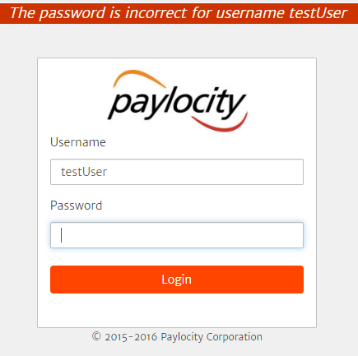

#### Environment:

local

#### Other Notes:

Attempted SQL injection, which failed. Used the following:

'-'

' '

'&amp;'

'^'

'*'

' or ''-'

' or '' '

' or ''&amp;'

' or ''^'

' or ''*'

"-"

" "

"&amp;"

"^"

"*"

" or ""-"

" or "" "

" or ""&amp;"

" or ""^"

" or ""*"

or true--

" or true--

' or true--

") or true--

') or true--

' or 'x'='x

') or ('x')=('x

')) or (('x'))=(('x

" or "x"="x

") or ("x")=("x

")) or (("x"))=(("x

### Case: Blank Password Error On Login Page

#### Expected Behavior

If the username has a value and the password is blank, then the login page will throw the error “Password cannot be blank.”

#### Current Behavior

The login page throws the error:

“Invalid login attempt. Please try again.”

When any data is provided to the username field and the password field is blank

#### Recreation

* Get to the login page
* Enter any text in the username field (abc)
* Leave the password field blank
* Receive the above error: “Invalid login attempt. Please try again.”

#### Screen Shot:

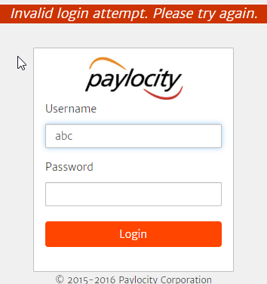

#### Environment:

local

#### Notes:

Looked into the included files and found the login script: “script.js” edited it to include this line:

var formPasswordLength = $("input").eq(1).val().length;

changed the first if statement to be: if (formPasswordLength==0)

and made the rest of the if statements else if statements. The error message now appears when no password is entered (at least for non-valid users). Also added validation for both the username and password being blank and just the username.

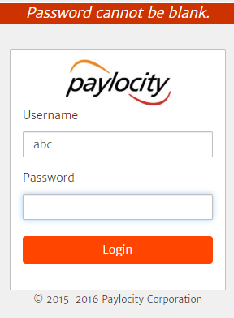

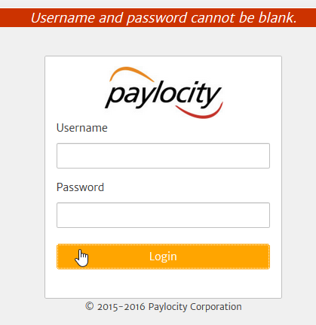

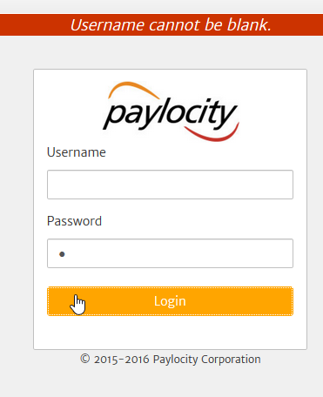

### Case: Caps Lock Toggle On Login Page

#### Expected Behavior

When in the password field, if the caps lock is toggled on, a message will appear indicating as such

#### Actual Behavior

No caps lock on message appears if caps lock is toggled on when in the password field

#### Recreation

* Get to the login page
* Go to the password field
* Toggle on the caps lock button
* Notice no message appears indicating caps lock is on (except for Edge)

#### Environment:

local

### Case: Error Messages Missing On Login Page

#### Expected Behavior

Error messages appear on the login page no matter the browser

#### Actual Behavior

Error messages on the login page do not appear in IE11, Edge browser

#### Recreation

* Get to the login page using IE11 or Edge browser
* Enter anything in the username field
* Leave the password field blank
* Click the Login button or type the Enter key
* Notice no error message appears like it does on any other browser
* This occurs for any error

#### Screen Shot

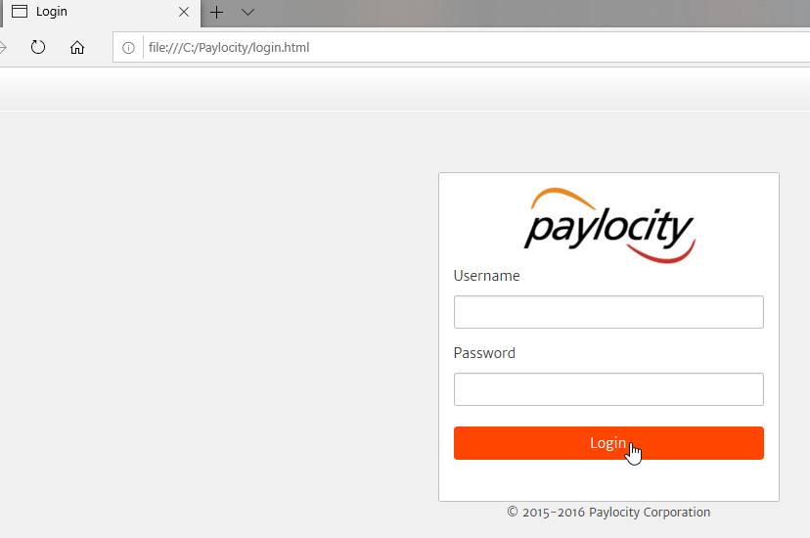

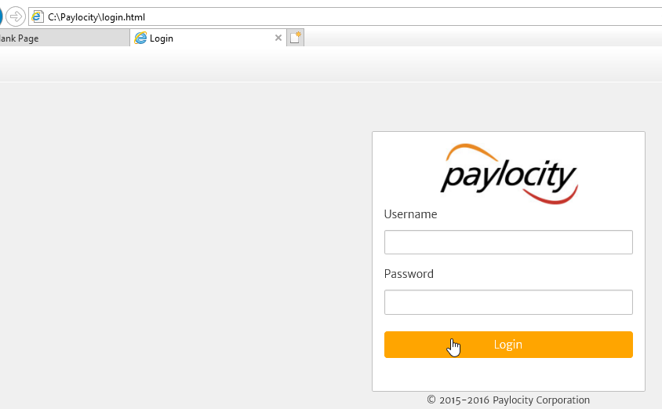

#### Environment:

local

### Case: Removed From Website

#### Expected Behavior

Using a keyboard key will not remove the user from the website

#### Actual Behavior

In Firefox, Vivaldi, and IE11, while on the Login page, using the Backspace key when the focus is on the Login button will remove the user from the website

#### Recreation

* Get to the login page
* Click into the username field
* Press the Tab key twice so the focus is on the Login button
* Press the Backspace key
* Notice the user is taken away from the website

#### Environment:

local

### Case: No Character Limit

#### Expected Behavior

The username and password fields would have some character limit to account for database limits

#### Actual Behavior

No limit appears to be present for either field

#### Recreation

* Get to login page
* Type in any length of characters into either field (username or password)
* Notice the amount of characters can keep going

#### Notes:

Typically no username or password will be as long as or longer than any database limit. Putting a limit on the amount of characters would be helpful to avoid hacking among other issues.

#### Environment:

local

### Case: No limit On Password Attempts

#### Expected Behavior

The user would have a limited number of attempts to enter a correct password before being disabled

#### Actual Behavior

The user may attempt username / password combinations as many times as desired, allowing malicious / fraudulent activity

#### Recreation

* Get to the login page
* Type in a valid username (userTest) in the username field
* Type in an invalid password
* Click the Login button
* Receive the error message: “The password is incorrect for username testUser”
* Repeat the previous three bullets ad nauseam noticing no new message appears indicating the user is running low on attempts, out of attempts or disabled

#### Environment:

local

### Case: Valid User With Invalid Password Throws An Error

#### Expected Behavior

A valid username entry with invalid username entry will throw an error indicating the user needs to try again, but not indicate the username is correct

#### Actual Behavior

Entering a valid username with an invalid password will throw an error indicating the username is correct, but the password is not: “The password is incorrect for username testUser.” This will allow malicious / fraudulent behavior to occur.

#### Recreation

* Get to the login page
* Type in a valid username (testUser) in the username field
* Type in an invalid password
* Click the Login button
* Receive the error: “The password is incorrect for the username testUser”
* Repeat the previous three bullets ad nauseam noticing no new message appears indicating the user is running low on attempts, out of attempts or disabled

#### Environment

Local

### Improvement Case: Reset Link

#### Current State

A user forgetting a username or password has no way of retrieving either

#### Suggestion

Supply a way for a user to retrieve / reset either the password or username, possibly through links and question / answers

### Improvement Case: Error Message Location

#### Current State

Error messaging is in one location: the top of the screen, above the login module

#### Suggestion

Break up the error messaging to be next to each field where the error is applicable and more easily seen by the user, possibly even highlighting each incorrect field in red

### Improvement Case: Login Lockout / Disable

#### Current State

A user account stays active no matter how many attempts are made to login

#### Suggestion

Limit the number of login attempts allowed before disabling the user and or temporarily banning the IP address. This would help fight fraudulent uses

## Benefits Dashboard

### Case: Add Blank Employee

#### Expected Behavior

Would not be able to leave any fields blank in the Add Employee & His dependents pop up blank

#### Actual Behavior

Able to submit new employee data without entering anything into the three fields

Recreation

* Get to the login page
* Type in a valid username (testUser) in the username field
* Type in a valid password (Test1234) in the password field
* Click the Login button
* Click the Add Employee button
* Click the Submit button in the new pop-up without completing any fields
* Notice the pop-up closes and a new line is added with blank employee information (last name, first name, dependents)

#### Screen Shot

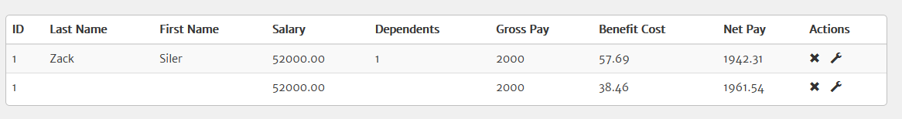

#### Environment

Local

### Case: Add Employee Pop-Up Title

#### Expected Behavior

Button name of Add Employee would match title of the pop-up activated

#### Actual Behavior

The button Add Employee and the associated pop-up titled Add Employee & His dependents mismatch. The button and title should match. The pop-up title appears to match the fields the pop-up contain.

#### Recreation

* Get to the login page
* Type in a valid username (testUser) in the username field
* Type in a valid password (Test1234) in the password field
* Click the Login button
* Click the Add Employee button
* Notice the pop-up header and the button are not named the same

#### Screen Shots





#### Notes

If this is changed, the title would also need to be changed. Just like a Save button doesn’t say what all it is saving, it keeps it general but still gives the user an idea of what is happening.

#### Environment

local

### Case: Add Employee Pop-Up Dependent Field Spelling And Case

#### Expected Behavior

The field labels and titles would be spelled correctly and casing would match

#### Actual Behavior

The Add Employee pop-up spells dependents with an ‘e’ and an ‘a’. The correct spelling of dependents is with an ‘e’. The title of the pop-up uses all uppercase except for dependents- should be all one case, but if ‘& His dependents’ is removed, this is a moot point.

#### Recreation

* Get to the login page
* Type in a valid username (testUser) in the username field
* Type in a valid password (Test1234) in the password field
* Click the Login button
* Click the Add Employee button
* Notice the lowercase in the title of the pop-up and then also the misspelling as ‘Dependants’ for the field label

#### Screen Shots

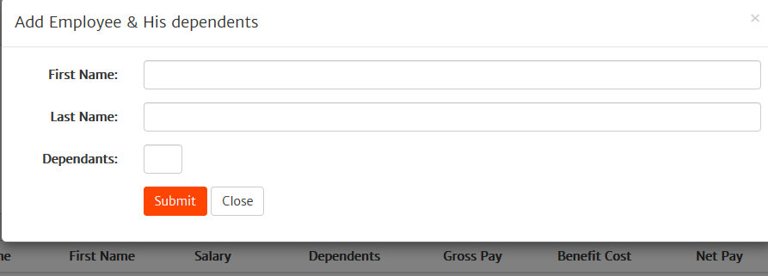

#### Environment

local

### Case: Add Employee Pop-Up No Field Validation

#### Expected Behavior

Each field has validation, throwing errors and/or warnings to the user, instructing them what to do to fix issues. There should also be an info blurb / instructions of what input is allowed / expected in a central area or next to each field, e.g. First Name and Last Name allow 256 characters. First name does not allow any input starting with an ‘A’ or ‘a’. Dependents must be an integer greater than or equal to 0, but not exceed 102.

#### Actual Behavior

Each field allows any input. The acceptance criterion of no first name beginning with ‘A’ or ‘a’ is not honored. Dependents are not integers 0 or greater (they are anything). There is no character limit in the form of stopping input or truncation. Emoji are even accepted. Entering in non-numeric values for dependent throws NaN errors for Benefit Cost and Net Pay, which indicates the calculations should account for unclean data. Negative numbers in the dependents field has the benefit cost field to calculate as a negative value as well. Could possibly be remedied by setting a range for dependents then have the user select a value from a drop down list. Doing so would eliminate NaN and negative number issues.

#### Recreation

* Get to the login page
* Type in a valid username (testUser) in the username field
* Type in a valid password (Test1234) in the password field
* Click the Login button
* Click the Add Employee button
* Start adding data to the First Name, Last Name, and Dependent fields as shown in the screen shots, e.g.
  + negative number for dependent
  + emoji for any/all fields
  + symbols for any/all fields
  + decimals for dependent
  + ‘A’ or ‘a’ for first name field by itself or with a word
  + Dependent values as high as 102 or higher

#### Screen Shots

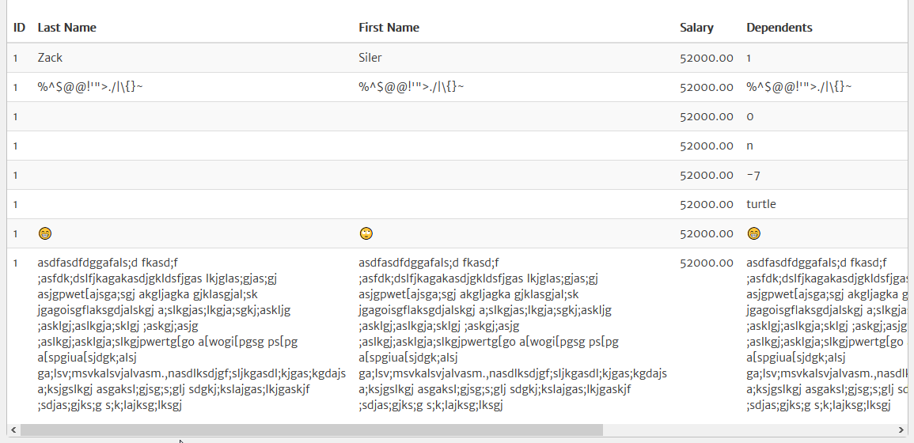

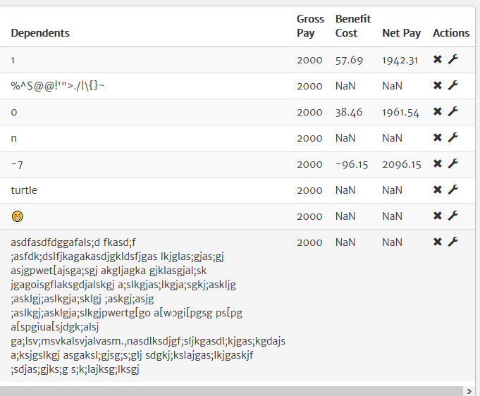

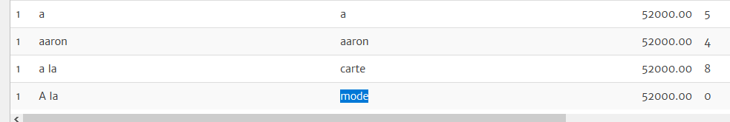

#### Environment

Local

### Case: Add Employee Allows Blank Data Entry (associated with last case)

#### Expected Behavior

The Add Employee pop-up has required fields

#### Actual Behavior

The Add Employee pop-up allows the submission of a new employee with no fields completed

#### Recreation

* Get to the login page
* Type in a valid username (testUser) in the username field
* Type in a valid password (Test1234) in the password field
* Click the Login button
* Click the Add Employee button
* Click the Submit button
* Notice the user is returned to the dashboard and a blank user entry is shown (fields from the pop-up are blank)

#### Screen Shots

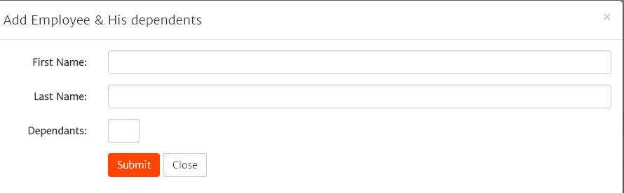

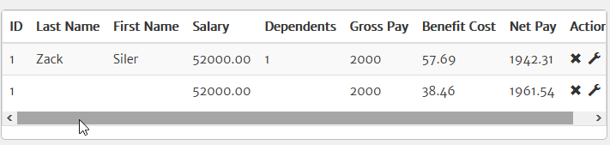

#### Environment

local

### Case: Add Employee Reducing Browser Size Dependent Field

Dependent field name moves to the other side of textbox when size of browser is reduced to a certain point instead of going above like the other two fields

#### Expected Behavior

Pop-up field labels should have the same relative positions when the browser is repositioned

#### Actual Behavior

When the browser is resized, just under half the screen, First Name and Last Name reposition to over the text field. The Dependents label moves to the right side of the text field.

#### Recreation

* Get to the login page
* Type in a valid username (testUser) in the username field
* Type in a valid password (Test1234) in the password field
* Click the Login button
* Click the Add Employee button
* Resize the browser, dragging the size down

#### Screen Shots

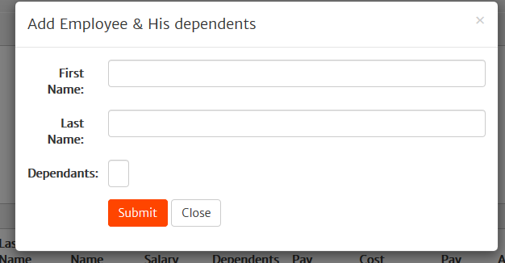

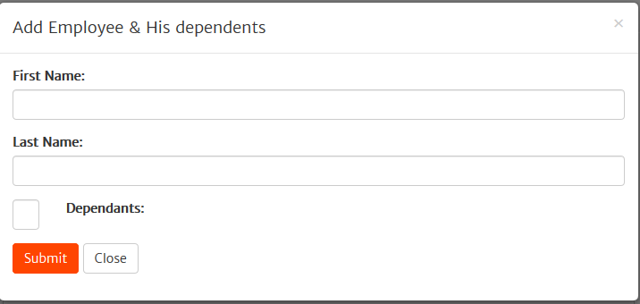

#### Environment

local

### Case: Add Employee Has No Employee ID Field / Middle Initial Field

#### Expected Behavior

Add Employee pop-up has a field to enter a unique employee ID by the employer, or designate creation by the application in the event the employer does not have one for employees. There would also be a field (not required) for middle name / initial for further identification. Any internal ID generated from SQL triggers, etc. that are not wanted by the employer are not displayed.

#### Actual Behavior

No employee ID field is present or middle initial field on the Add Employee pop-up. When an employee is added, the Dashboard contains an ID, which appears to be system generated.

#### Recreation

* Get to the login page
* Type in a valid username (testUser) in the username field
* Type in a valid password (Test1234) in the password field
* Click the Login button
* Click the Add Employee button
* Notice no employee ID field is present nor middle name / initial
* Add employee information and click the Submit button
* Notice the new employee has an ID not entered by the user

#### Screen Shots



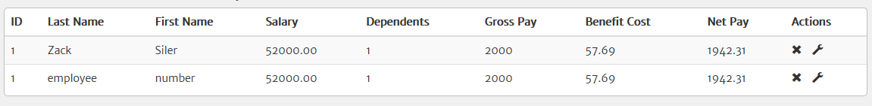

#### Environment

local

### Case: Add Employee Does Not Iterate ID

#### Expected Behavior

When using Add Employee, the new employee would receive an increase in the value of the ID- “n+1”

#### Actual Behavior

When using Add Employee, the new employee always receives the same ID

#### Recreation

* Get to the login page
* Type in a valid username (testUser) in the username field
* Type in a valid password (Test1234) in the password field
* Click the Login button
* Click the Add Employee button
* Add employee information and click the Submit button
* Notice the new employee has an ID the same as the first employee
* Repeat the last three steps

#### Screen Shots



#### Environment

local

### Case: Add Employee Enter Key Only Works On Buttons

#### Expected Behavior

Pressing the Enter key on the last entry field (Dependents) for the Add Employee pop-up works the same as clicking the Submit button since it is all data entry

#### Actual Behavior

The user must press the Tab key to get to the Submit button then press the Enter key or click Submit. The Escape key does work at any time to exit the pop-up, so would think this would work

#### Recreation

* Get to the login page
* Type in a valid username (testUser) in the username field
* Type in a valid password (Test1234) in the password field
* Click the Login button
* Click the Add Employee button
* Add employee information
* In the Dependents field press the Enter key
* Notice nothing happened
* Press the Tab key to set the focus to the Submit button
* Press the Enter key
* Notice the employee information was added

#### Screen Shots

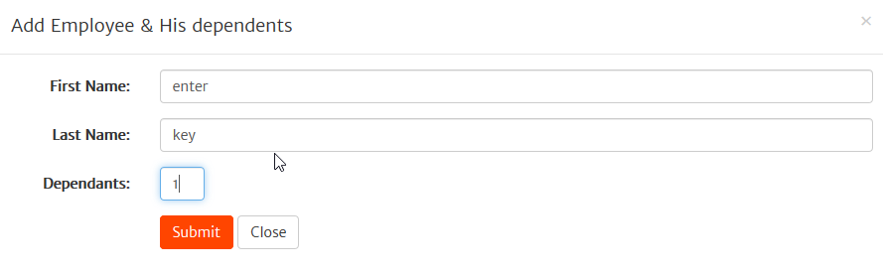

#### Environment

local

### Case: Unable To Login Using IE or Edge

#### Expected Behavior

Able to use any modern browser to access the application

#### Actual Behavior

Unable to use IE11 or Edge to access the application (unable to login properly, credentials entered, but not able to get past login page)

#### Recreation

* Get to the login page
* Type in a valid username (testUser) in the username field
* Type in a valid password (Test1234) in the password field
* Click the Login button
* Notice the page refreshes but does not proceed to the Dashboard, just removes credentials

#### Environment

local

Case: Add Employee Backspace On Buttons Logs Out User   
Expected Behavior

A Backspace key press has no adverse effect when the focus is on a button

#### Actual Behavior

When the focus is on the Submit button in the Add Employee pop-up and the Backspace key is pressed, the user is logged out in Vivaldi and Firefox browsers (Chrome is unaffected)

#### Recreation

* Get to the login page using Firefox or Vivaldi browsers
* Type in a valid username (testUser) in the username field
* Type in a valid password (Test1234) in the password field
* Click the Login button
* Click the Add Employee button
* Press the Tab key until the focus is on the Submit button
* Press the Backspace key
* Notice the user is logged out

#### Environment

Local

### Case: Add Employee No Duplicate Data Check

#### Expected Behavior

Duplicate Employee Data is not possible to enter through Add Employee

#### Actual Behavior

It is possible to enter duplicate data through Add Employee

#### Recreation

* Get to the login page
* Type in a valid username (testUser) in the username field
* Type in a valid password (Test1234) in the password field
* Click the Login button
* Click the Add Employee button
* Enter duplicate information into the fields (Zack Siler 1) and click the Submit button
* Notice there is no error indicating the data is duplicate and the entry appears on the Dashboard

#### Screen Shots

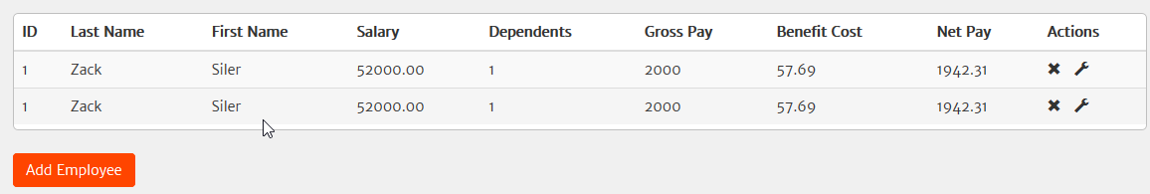

#### Environment

Local

### Case: Edit Employee No Duplicate Data Check

#### Expected Behavior

Duplicate Employee Data is not possible to enter through Edit Employee

#### Actual Behavior

It is possible to enter duplicate data through Edit Employee

#### Recreation

* Get to the login page
* Type in a valid username (testUser) in the username field
* Type in a valid password (Test1234) in the password field
* Click the Login button
* Click the Add Employee button
* Enter new information (none duplicated) into the fields and click the Submit button
* Click the Edit button to the far right of the new employee
* Enter duplicate information into the fields (Zack Siler 1) and click the Submit button
* Notice there is no error indicating the data is duplicate and the entry appears on the Dashboard

#### Screen Shots



#### Environment

local

### Case: Add Employee Close, X Out, Escape Out, and Click Out Does Not Remove Data

#### Expected Behavior

Getting out of the Add Employee pop-up resets it, no matter which way the exit is done

#### Actual Behavior

Any data entered in the Add Employee pop-up never resets unless it is submitted. Clicking the Close button, the X in the top right, tapping the Escape key, or clicking outside the pop-up all exit the pop-up, but opening the pop-up again shows the same entered data.

#### Recreation

* Get to the login page
* Type in a valid username (testUser) in the username field
* Type in a valid password (Test1234) in the password field
* Click the Login button
* Click the Add Employee button
* Enter information into the fields
* Exit out of the pop-up (Close button, X button, Escape key, clicking outside of the pop-up)
* Click the Add Employee button
* Notice all entered information is still present

#### Screen Shots

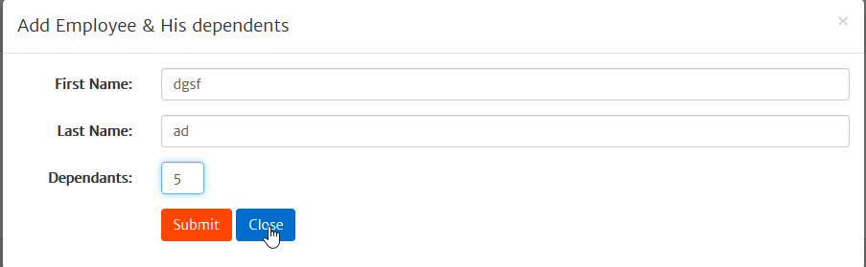

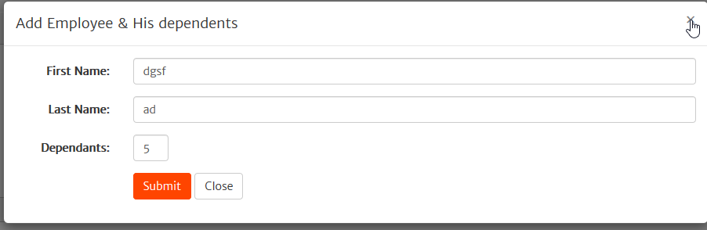

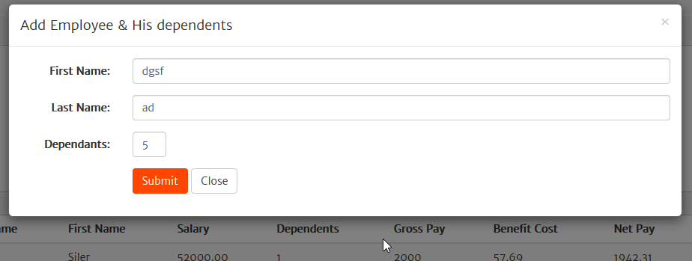

#### Environment

local

### Case: Edit Employee Function Header

#### Expected Behavior

When clicking the Edit button, the pop-up has Edit in the header title

#### Actual Behavior

The pop-up for the Edit functionality shows a header with the same title as the Add Employee pop-up, Edit is not in the title

#### Recreation

* Get to the login page
* Type in a valid username (testUser) in the username field
* Type in a valid password (Test1234) in the password field
* Click the Login button
* Click the Edit button in the employee row on the far right
* Notice the header of the pop-up is titled the exact same as the Add Employee pop-up “Add Employee & His dependents

#### Screen Shots

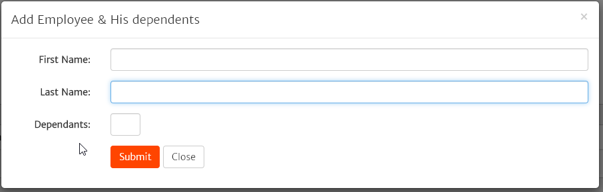

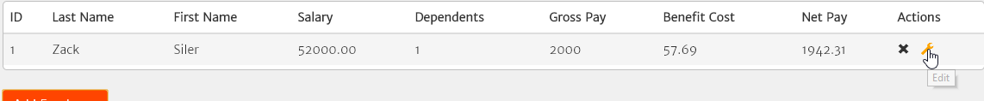

#### Environment

Local

### Case: Edit Employee Then Add Employee

#### Expected Behavior

Data clears when going from Edit Employee to Add Employee

#### Actual Behavior

Data remains persistent from Edit Employee to Add Employee

#### Recreation

* Get to the login page
* Type in a valid username (testUser) in the username field
* Type in a valid password (Test1234) in the password field
* Click the Login button
* Click the Add Employee button
* Save a new employee
* Click the Add Employee button
* Notice no information carried over
* Add employee information but close out
* Click the Edit button in the employee row on the far right on an employee
* Close out of the pop-up
* Click the Add Employee button
* Notice the information from the edited employee carried over into Add Employee

#### Screen Shots

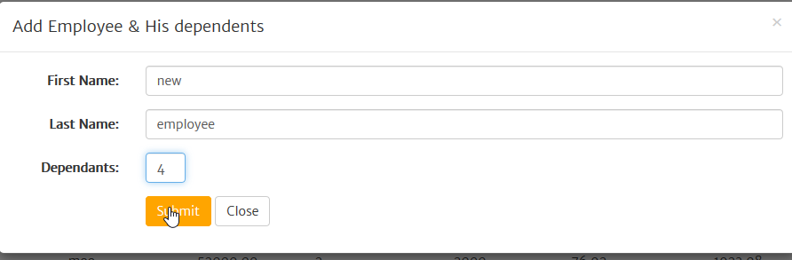

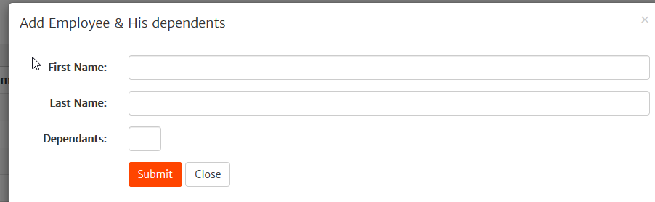

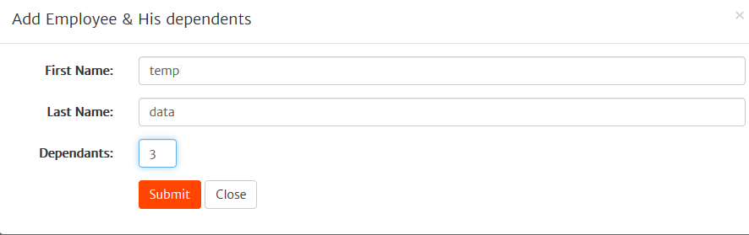

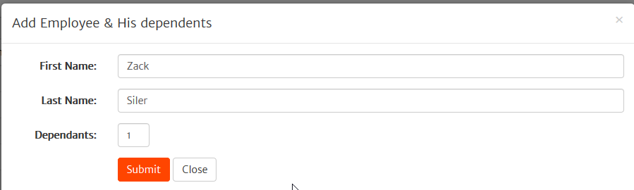

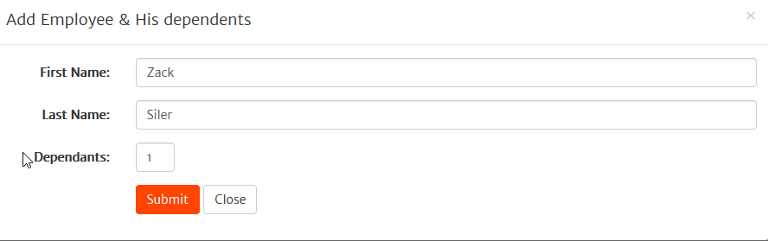

#### Environment

Local

### Case: Refreshing Page Removes Added Employees

#### Expected Behavior

All added data persists even when the page is refreshed

#### Actual Behavior

Added data is lost when the page is refreshed or the user logs out and back in

#### Recreation

* Get to the login page
* Type in a valid username (testUser) in the username field
* Type in a valid password (Test1234) in the password field
* Click the Login button
* Click the Add Employee button
* Save a new employee
* Repeat the last two steps 2-3 times
* Click the browser refresh button
* Notice all new data is lost / removed from the page

#### Screen Shots

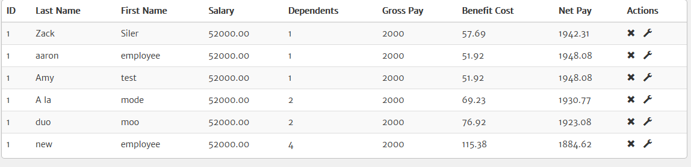

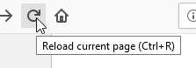

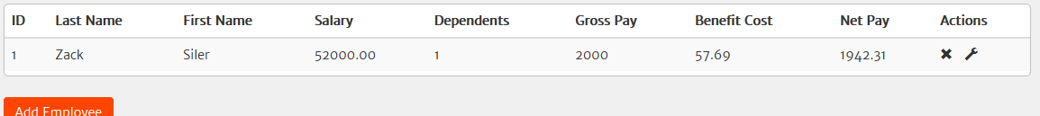

#### Environment

local

### Case: Delete Button Does Not Work

#### Expected Behavior

The Delete button removes that particular row of data

#### Actual Behavior

The Delete button does not remove any data

#### Recreation

* Get to the login page
* Type in a valid username (testUser) in the username field
* Type in a valid password (Test1234) in the password field
* Click the Login button
* Click the Add Employee button
* Save a new employee
* Click the delete button on the far right of each employee
* Notice both employees remain

#### Screen Shots

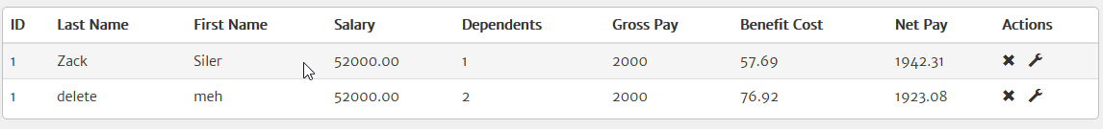

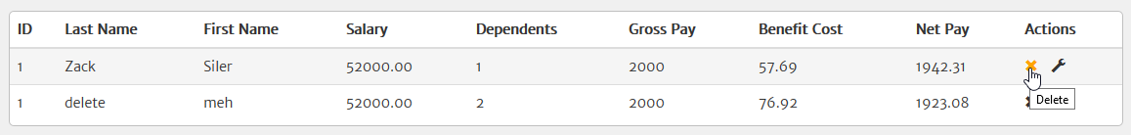

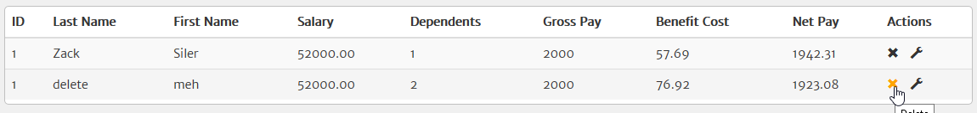

#### Environment

Local

#### Note

I have fixed the Delete function to now work properly. There was an issue called out in the browser console with the Spinner not existing. Looking at the code, the implementation was not quite right. Updated it to have a spinner class in the html, a cdn reference to the spinner.js, and fixed which row was being deleted – the selected row was not being deleted, the one above was. Data persistency is still a problem since there is no save function that saves to the employee.xml file

### Case: Dashboard Flips Names Entered

#### Expected Behavior

The entered information on the Add Employee / Edit Employee pop-ups for the employee first name and last name continue to be that on the dashboard. The Last Name and First Name fields are in the same order as well. Whichever order is chosen for the names should be stuck to in all places

#### Actual Behavior

The fields and positions are flipped so the employee information appears in the right order, but the data is not actually correct

#### Recreation

* Get to the login page
* Type in a valid username (testUser) in the username field
* Type in a valid password (Test1234) in the password field
* Click the Login button
* Click the Add Employee button
* Add a first name to the First Name text box (first)
* Add a last name to the Last Name text box (last)
* Add a number to the dependents field
* Click the Submit button
* Notice the name flipping on the Dashboard (first=last name, last=first name)

#### Screen Shots

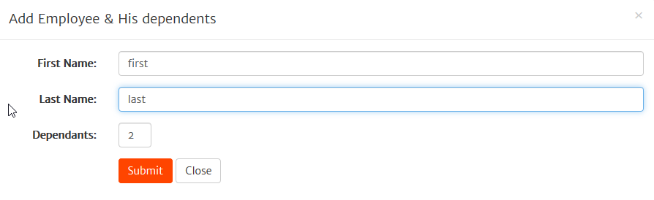

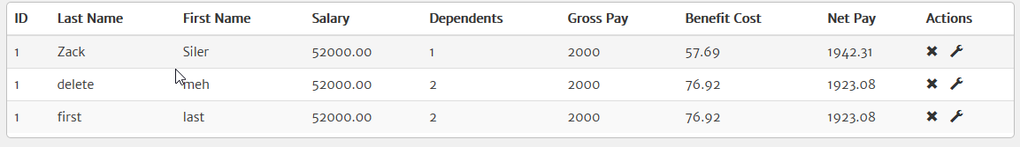

#### Environment

local

### Case: Dashboard Grouping Data

#### Expected Behavior

All entered data would show up grouped together on the benefits page as it is like data, the other data is all currency

#### Actual Behavior

The entered data is split by the salary information showing between the first name column and dependents column. Would want to get business owner input, UX, and customer input to see if this is what is desired.

#### Recreation

* Get to the login page
* Type in a valid username (testUser) in the username field
* Type in a valid password (Test1234) in the password field
* Click the Login button
* Look at the columns on the dashboard to see the salary column between first name and dependents columns

#### Screen Shots

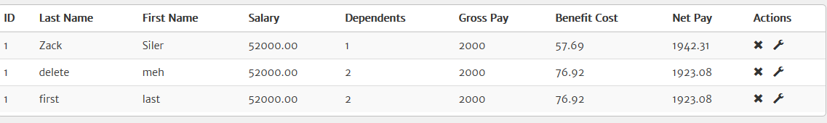

#### Environment

Local

### Case: Dashboard Labels

#### Expected Behavior

Currency is fully explained in reference to time, e.g. what are the pay periods, etc.

#### Actual Behavior

No time reference is given, just numbers

#### Recreation

* Get to the login page
* Type in a valid username (testUser) in the username field
* Type in a valid password (Test1234) in the password field
* Click the Login button
* Look at the columns on the dashboard to see the currency does not have any timeframe associated, e.g. per year, per week, per month, per week, etc. to full qualify the currency

#### Screen Shots



#### Environment

local

### Case: Dashboard Money Value

Expected Behavior

All currency indicates what type it is using be it dollars, pesos, euros, loonies, or yen, be it in the column headers or next to all the entries in each row

Actual Behavior

No indication of what type the currency is

#### Recreation

* Get to the login page
* Type in a valid username (testUser) in the username field
* Type in a valid password (Test1234) in the password field
* Click the Login button
* Look at the columns on the dashboard to see the currency does not have any actual denotation of what type it is, e.g. ($)

#### Screen Shots



#### Environment

local

### Case: Dashboard Gross Pay Precision

#### Expected Behavior

All currency should have the same precision

#### Actual Behavior

The gross pay column does not go out to the hundredths like the other currency columns

#### Recreation

* Get to the login page
* Type in a valid username (testUser) in the username field
* Type in a valid password (Test1234) in the password field
* Click the Login button
* Look at the gross pay column on the dashboard
* Notice the precision is to the 1s an not to the hundredths like the rest of the currency columns

#### Screen Shots



#### Environment

Local

### Case: Dashboard Address Security

The username is directly referenced in the url – can use any username to access the account

#### Expected Behavior

Page URLs are secure, and do not contain any user information

#### Actual Behavior

The dashboard URL contains the username allowing the session / user information to be stolen, login screen to be bypassed

#### Recreation

* Get to the login page
* Type in a valid username (testUser) in the username field
* Type in a valid password (Test1234) in the password field
* Click the Login button
* Notice the URL contains “username=testUser”
* Copy the URL
* Close the current session
* Paste the copied URL into the address bar and go
* Notice the Dashboard appears, bypassing the login screen

#### Screen Shots

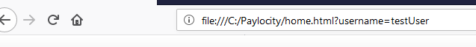

#### Environment

Local

### Case: Dashboard Address Matches Page

The page the user is directed to for the dashboard doesn’t match the url (home vs. benefits dashboard)

#### Expected Behavior

The URL the user is directed to matches the actual page on which they land

#### Actual Behavior

The benefits dashboard is named home.html instead of benefitsdashboard.html or dashboard.html. The login page follows common nomenclature.

#### Recreation

* Get to the login page
* Type in a valid username (testUser) in the username field
* Type in a valid password (Test1234) in the password field
* Click the Login button
* Notice the URL indicates home instead of the benefits dashboard

#### Screen Shots



#### Environment

local

### Case: Session Expiration

The session does not expire, can navigate away even and just hit the back button to return

#### Expected Behavior

The session expires after a certain amount of time without activity

#### Actual Behavior

The session never expires

#### Recreation

* Get to the login page
* Type in a valid username (testUser) in the username field
* Type in a valid password (Test1234) in the password field
* Click the Login button
* Let the page sit idle for 10,15,30 minutes, 1 hour, overnight
* Notice the page never expires, letting the user complete Add Employee and Edit Employee Functions, view the page, etc.

#### Environment

local

### Case: No Logout Button

#### Expected Behavior

The user is provided a way to logout from any page they navigate to

#### Actual Behavior

The benefits dashboard has no logout button

#### Recreation

* Type in a valid password (Test1234) in the password field
* Click the Login button
* Notice there is no logout button

#### Screen Shots

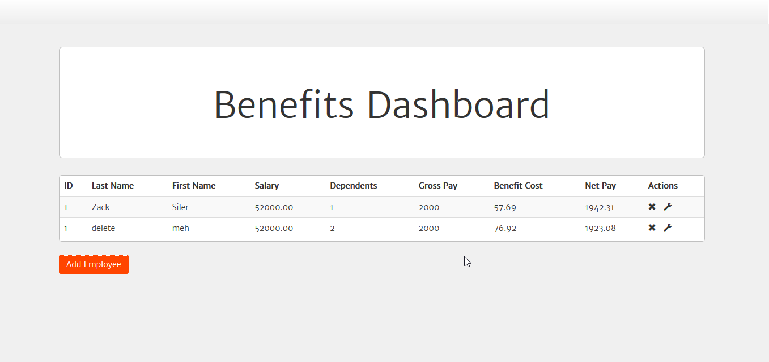

#### Environment

Local

### Improvement Case: Dashboard Actions

#### Current State

There is an action column to the far right with both the delete and edit functions close to each other

#### Suggestion

Separate the buttons to prevent mistake clicks (delete on the right, edit to the left). Add color to indicate they are actionable. Remove them from the table and remove the action column. Should consult with business, UX, and clients for assessment.

### Improvement Case: WCAG Compliance

#### Current State

Not everything is WCAG compliant.

#### Suggestion

At least allow tabbing to move through data table, access the edit and delete buttons

### Improvement Case: Dashboard Name

Reduce Size of name or make reducible, the important aspect of page is the data, not the name of the page

#### Current State

The name of the benefits dashboard is not as important as the data therein, but the name of it is quite large

#### Suggestion

Reduce the size of the jumbotron to allow more room for the important part of the page: the data. At the least make it reducible or collapsible. May wish to run by business, UX

### Improvement Case: Remove uselessBlueHeader

#### Current State

There is a div called uselessBlueHeader in the login and benefits dashboard at the top taking up room that does not need to be, hence the name supposedly

#### Suggestion

Remove this and any references from the code

### Improvement Case: Remove Code In Employee.js

#### Current State

In the function loadEmployeeDetails(), there is var employer_total_cost = 0 and then at the end of the function it is just written out. The var is not actually used at all

#### Suggestion

Remove the var and the reference as it serves no purpose, or see if there was some initial purpose for it that still needs to be implemented that we may have missed. I’ve commented it out to ensure it does not affect current functionality.

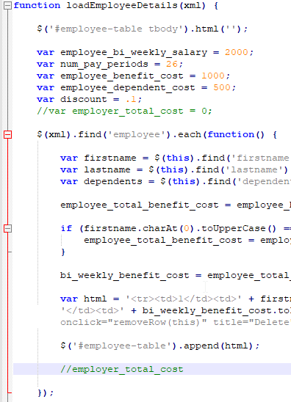

### Improvement Case: Remove Code In Login.html

#### Current State

There is whole other login code commented out. Commenting out the current code shows it looks entirely different than the current version

#### Suggestion

Remove / archive through repositories to clean up the code or if this is actual desired code something needs to be done to make both work in unison (e.g. one is for mobile, one is for browser, though the current code works for both…seems the commented out was just old code that was not removed. The below screen shot is what it looks like.

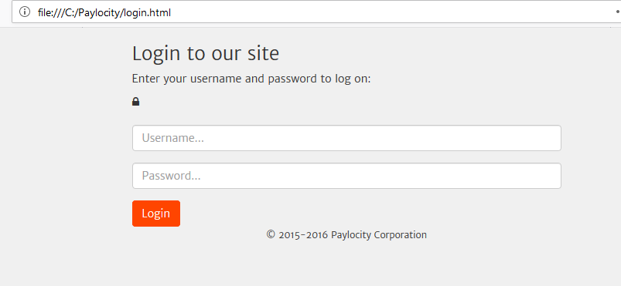

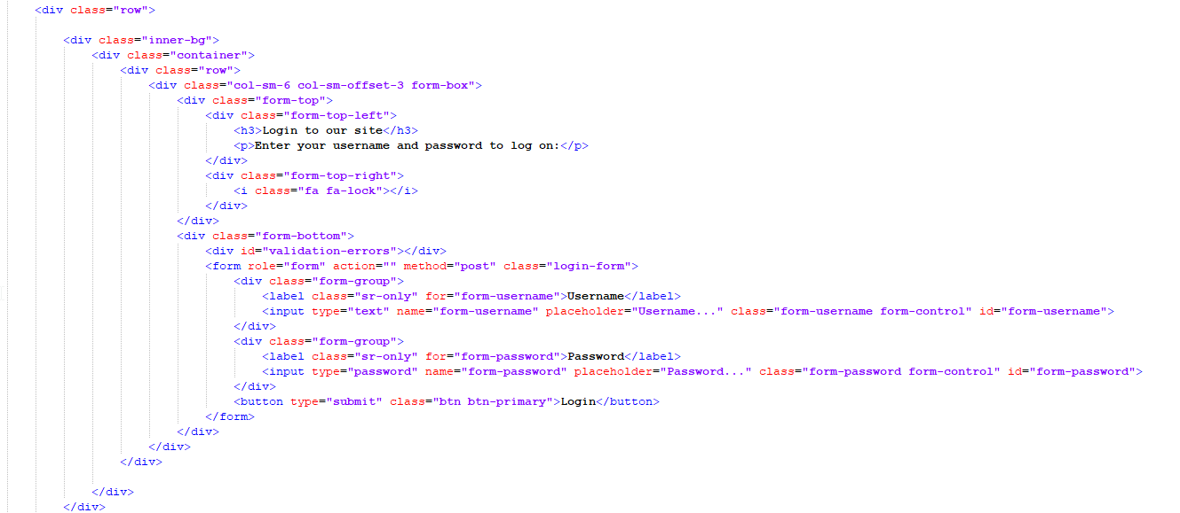

### Improvement Case: Remove Code Script.js

#### Current State

There is commented out code line 23 – 33 referencing specific passwords that is commented out

#### Suggestion

Remove / archive this code unless this is really needed, though seems it was a test run to see if for validation worked as any other password would take the user to the home page

